Youth Demographic Estimation Tool (YDE Tool) Tutorial

This tool is used to get demographic estimates for youth attendance at sites that we do not currently have data for in our SEEDS system. Visual estimates are no longer allowed from the USDA, and youth cannot fill out a demographic card themselves.

Step 1: Download Estimation Tool from https://www.azhealthzone.org/collaborators/documents/category/forms/

Step 2: In order to use this form, you will need to gather the following data from your site’s administration to enter into the form:

- Participant SNAP Status
- Participant Age and Gender
- Participant Race and Ethnicity

Once this information has been gathered, enter it in to the blue spaces highlighted here. Make sure that all totals of SNAP Status, Age and Gender, and Race and Ethnicity match.
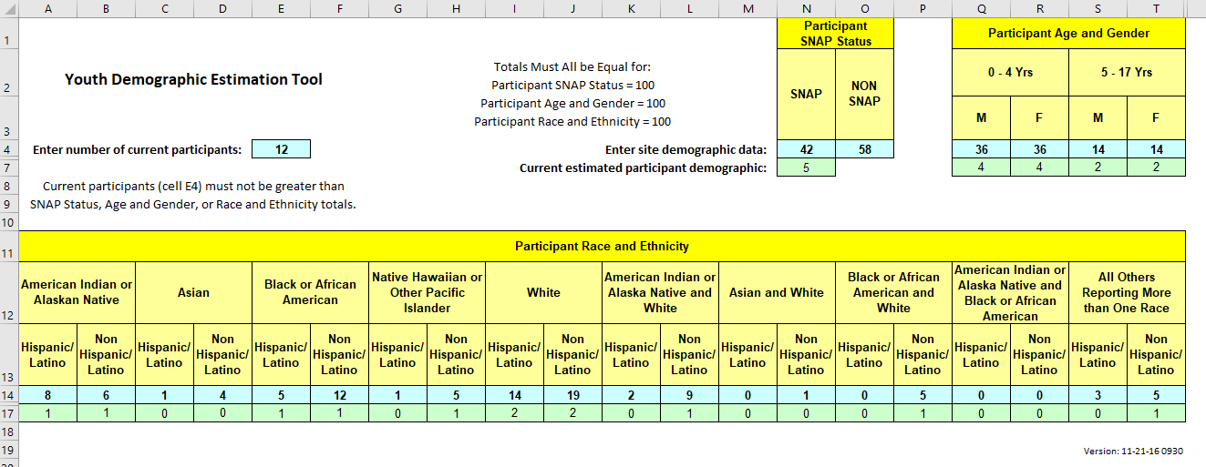
Step 3: Enter the number of participants at the site during the action you are entering into SEEDS in the blue box highlighted below:

Step 4: Enter the numbers in the green bar into the corresponding parts in SEEDS.

